**Smart Bin**

**Circuit Diagram**

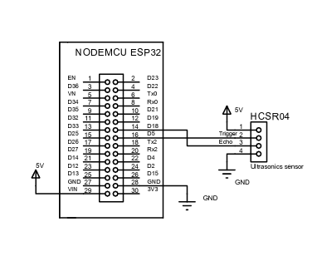

**Circuit Diagram Explanation**

The ESP32 is a microcontroller board that can be used for a variety of purposes, including reading data from sensors and controlling outputs. The ultrasonic sensor is a device that uses sound waves to measure distance. In this circuit, the ultrasonic sensor is likely being used to measure the distance to an object, such as the level of the waste in a waste bin.

ESP32 board: This is the main component of the circuit. It provides the processing power and I/O connections for the sensor and other devices.

Ultrasonic sensor: This sensor sends out sound waves and measures the time it takes for the echoes to return. This time can be used to calculate the distance to the object in front of the sensor.

Digital pin5 of ESP32 connected to the Trigger pin of the ultrasonic sensor, which sends a signal to the ultrasonic sensor to send out sound waves. The Echo pin of the ultrasonic sensor is connected to the Digital pin18 of the Esp32 which reads the time it takes for the echoes to return from the sensor. The ESP32 uses this time to calculate the distance to the object in front of the sensor.

This distance is then sent to the MQTT server.

**Programming Language Used for Hardware: Embedded C**